**Experiment / Assignment / Tutorial No. ___7___**

**Grade: AA / AB / BB / BC / CC / CD /DD**

**Signature of the Staff In-charge with date**

|  |
| --- |
| **Batch: B1 Roll No.: 1611079 Experiment / assignment / tutorial No.: 7** |

|  |
| --- |
| **Title:** 3-bit Synchronous Counter |

**______________________________________________________________________________**

**Objective:** Design of 3 bit Synchronous counter using JK flip flop

**_____________________________________________________________________________**

**Expected Outcome of Experiment:**

**CO2:** Use different minimization technique and solve combinational circuits, synchronous & asynchronous sequential circuits.

**_____________________________________________________________________________**

**Books/ Journals/ Websites referred:**

* R. P. Jain, “Modern Digital Electronics”, Tata McGraw Hill
* M .Morris Mano, “Digital Logic & computer Design”, PHI
* A.P.Godse, D.A.Godse, “Digital Logic Design”
* http://www.fatih.edu.tr/~aliadam/EEE122A/EEE122Ch6COUNTERS.pdf

**Pre Lab/ Prior Concepts:**

A counter is a register capable of counting number of clock pulse arriving at its clock input. Counter represents the number of clock pulses arrived. A specified sequence of states appears as counter output. This is the main difference between a register and a counter. There are two types of counter, synchronous and asynchronous. In synchronous common clock is given to all flip flop and in asynchronous first flip flop is clocked by external pulse and then each successive flip flop is clocked by Q or Q output of previous stage. A soon the clock of second stage is triggered by output of first stage. Because of inherent propagation delay time all flip flops are not activated at same time which results in asynchronous operation.

**Implementation Details:**

**Characteristic Table for 3 bit UP counter**

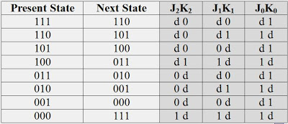

**Truth Table for 3 bit UP Counter**

|  |  |  |  |  |
| --- | --- | --- | --- | --- |
| **Present State**  **QA QB QC** | **Next State**  **QA+1 Q B+1 QC+1** | **A**  **JA KA** | **B**  **JB KB** | **C**  **JC KC** |
| 0 0 0 | 0 0 1 | 0 X | 0 X | 1 X |
| 0 0 1 | 0 1 0 | 0 X | 1 X | X 1 |
| 0 1 0 | 0 1 1 | 0 X | X 0 | 1 X |
| 0 1 1 | 1 0 0 | 1 X | X 1 | X 1 |
| 1 0 0 | 1 01 | X 0 | 0 X | 1 X |
| 1 0 1 | 1 1 0 | X 0 | 1 X | X 1 |
| 1 1 0 | 1 1 1 | X 0 | X 0 | 1 X |
| 1 1 1 | 0 0 0 | X 1 | X 1 | X 1 |

**K Map**

**K Map**

QA\QBQC

|  |  |  |  |
| --- | --- | --- | --- |
| X1 | X2 | 13 | 02 |
| 04 | 05 | 17 | 16 |

KA=QBQC

QA\QBQC

|  |  |  |  |
| --- | --- | --- | --- |
| X1 | X2 | 13 | 02 |
| X4 | X5 | 17 | 06 |

KB=QC

QA\QBQC

|  |  |  |  |
| --- | --- | --- | --- |
| X0 | 11 | 13 | X2 |
| X4 | 15 | 17 | X6 |

KC=1

QA\QBQc

|  |  |  |  |
| --- | --- | --- | --- |
| 00 | 01 | 13 | 02 |
| X4 | X5 | X7 | X6 |

JA=QBQC

QA\QBQC

|  |  |  |  |
| --- | --- | --- | --- |
| 00 | 11 | X3 | X2 |
| 04 | 15 | X1 | X6 |

JB=QC

QA/QBQC

|  |  |  |  |
| --- | --- | --- | --- |
| 10 | X1 | X3 | 12 |
| 05 | X5 | X7 | 16 |

JC=1

**Logic Diagram for 3 bit UP counter**

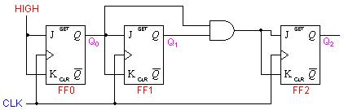

**Timing Diagram for 3 bit UP counter**

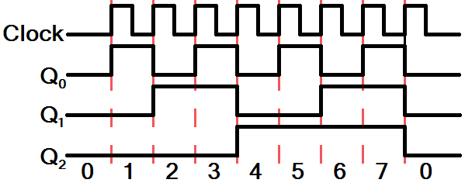

**Conclusion: Hence the concept of synchronous counter was understood and 3 bit synchronous counter was designed, studied and implemented.**

**Post Lab Descriptive Questions**

1. Draw logic diagram for mod-2 synchronous down counter.

